Modified 4 Bus Test System
The following systems are modifications to the IEEE 4 Node Test Feeder with a delta-grounded wye step down transformer. The top system in Figure C.1 is the base system which is purely intended for static power flow, the middle system incorporates a pv system and a padmount transformer, the bottom system incorporates an induction motor

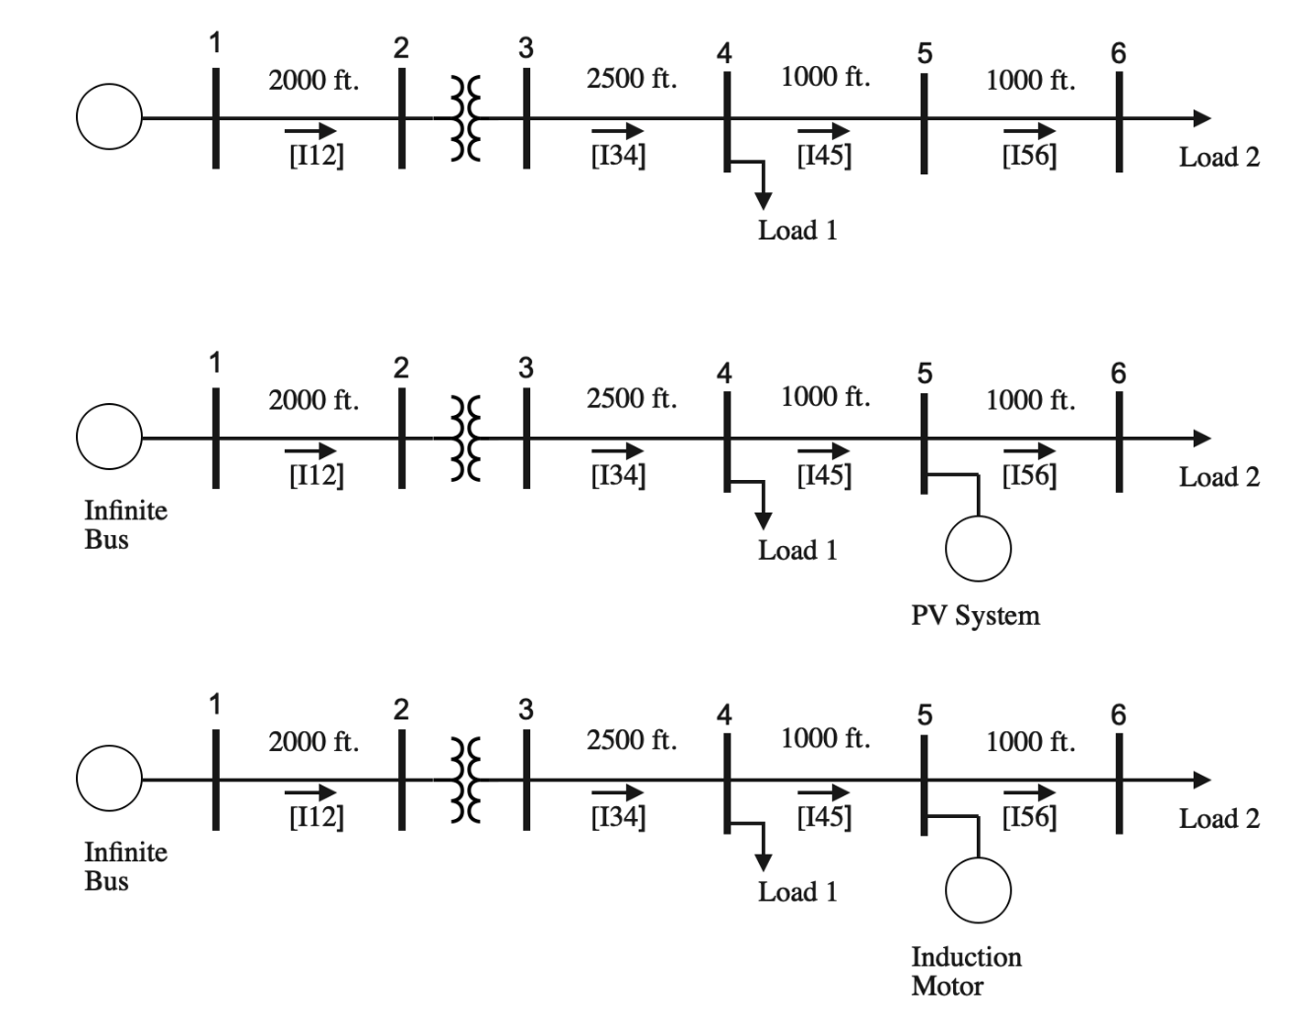
Figure C.1—4-bus Test System with Induction Motor and PV

Nodes 1-4 have not been modified.

System Data

Both the primary line (Node 1-Node 2) and the secondary lines (Node 3-Node 4), (Node 4-Node 5), and (Node 5-Node 6) will be constructed using the pole configuration shown below.

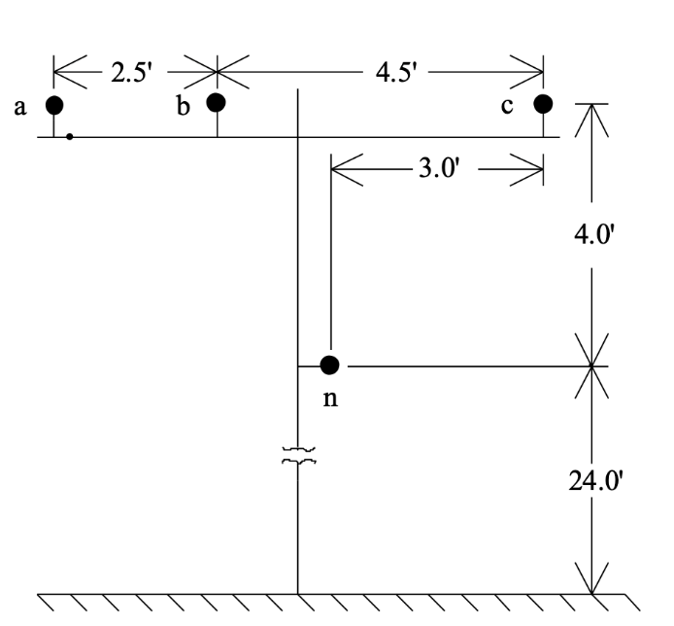

Phase Conductor: 336,400 26/7
GMR = 0.0244 ft., Resistance = 0.306 Ω/mile, Diameter = 0.721 inch

Neutral Conductor: 4/0 6/1 ACSR
GMR = 0.00814 ft., Resistance = 0.592 Ω/mile, Diameter = 0.563 inch
Figure C.2—Overhead line construction data

The source is a 12.47 kV line-to-line infinite bus.

The transformer has the following:

Connection | kVA | kVLL-high | kVLL-low | R-% | X-%
Step-Down | 6000 | 12.47 | 4.16 | 1.0 | 6.0

Load 1 Data:

 | Balanced | Unbalanced
Phase-1
kW | 1800 | 1275
Power Factor | 0.9 lag | 0.9 lag
Phase-2
kW | 1800 | 1800
Power Factor | 0.9 lag | 0.95 lag
Phase-3
kW | 1800 | 2375
Power Factor | 0.9 lag | 0.85 lag

Load 2 Data:

 | Balanced | Unbalanced
Phase-1
kW | 200 | 175
Power Factor | 0.9 lag | 0.9 lag
Phase-2
kW | 200 | 225
Power Factor | 0.9 lag | 0.95 lag
Phase-3
kW | 200 | 200
Power Factor | 0.9 lag | 0.85 lag

Motor Data:

Ratings:

Conn | Conn | kV | kW | kVA | Pole | rpm
IM | D | 0.48 | 372 | 478 | 4 | 1791

Dynamic Parameters:

H | D | Rs | Rr | Xs | Xr | Xm | m
1.6 | 1 | 0.007 | 0.0062 | 0.0409 | 0.0267 | 3.62 | 2.0

PV Data:

Ratings:
Conn | Ph-1 | Ph-1 | Ph-2 | Ph-2 | Ph-3 | Ph-3
 | kVA | pf | kVA | pf | kVA | pf
D | 120 | 0.95 | 120 | 0.95 | 120 | 0.95

Dynamic Parameters:

R | X | Kp | kVDC | KP Tol | Safe Voltage
0.5 | 0.5 | 0.01 | 0.03 | 0.1 | 0

Padmount transformer:

kVA | kV-high | kV-low | R - % | X - %
500 | 4.16 – Gr.W | 0.48 – Gr.W | 1.1 | 2

